WEEK 3 REPORT
Advanced Data Analysis and Visualization in Logistics
Submitted By:
Romeena Shaikh
Internship Domain:
Data Science
Week:
Week 3 - Advanced Data Analysis and Visualization in Logistics
Organization:
Yuva Intern
Date of Submission:
November 2026

Table of Contents
- Introduction
- Dataset Overview
- Descriptive Statistics
- Central Tendency Analysis
- Delivery Time Distribution Analysis
- Boxplot Analysis
- Correlation Analysis
- Distance vs Delivery Time Analysis
- Monthly Order Analysis
- Business Insights
- Python Code Illustration
- Conclusion

1. Introduction
Exploratory Data Analysis (EDA) is a crucial stage in the data science process that helps uncover patterns, relationships, and trends within data. In logistics analytics, EDA enables organizations to understand delivery performance, identify operational bottlenecks, and support better decision-making.
This report focuses on analyzing the cleaned logistics dataset prepared during Week 2. Various statistical techniques and visualization methods were applied to gain insights into delivery performance, customer order patterns, and factors affecting delivery duration.

2. Dataset Overview
The analysis was conducted using the cleaned Olist E-Commerce Delivery Time Dataset.
Attribute | Value
Records | 91,582
Features | 24
Missing Values | 0
Numerical Features | 19
Categorical Features | 5
The dataset contains information related to customer orders, freight costs, product dimensions, delivery distance, payment details, and delivery performance metrics.

3. Descriptive Statistics
The dataset was summarized using statistical measures such as mean, median, mode, standard deviation, minimum value, and maximum value.
Delivery Time Statistics
Metric | Value
Mean | 11.05 Days
Median | 9.91 Days
Mode | 10.22 Days
Standard Deviation | 6.09 Days
Minimum | 0.53 Days
Maximum | 29.15 Days
These statistics provide an overall understanding of delivery performance across the dataset.

4. Central Tendency Analysis
Central tendency measures describe the typical delivery duration observed in the dataset.
The average delivery time was approximately 11.05 days, while the median delivery time was 9.91 days. The mode was 10.22 days, indicating that the most frequent delivery duration was around ten days.
Since the mean value is slightly higher than the median, the distribution exhibits a mild positive skew. This suggests that a smaller number of longer deliveries slightly increase the overall average delivery time.

5. Delivery Time Distribution Analysis
A histogram was used to visualize the distribution of delivery times.
Observations
- Most deliveries occurred between 5 and 15 days.
- Peak delivery frequency was observed around 7 to 10 days.
- The distribution displayed a right-skewed pattern.
- Extremely long delivery durations were less common.

Interpretation
The histogram indicates that most orders are delivered within a moderate time range. Although some deliveries take longer, the majority of deliveries are completed within two weeks.
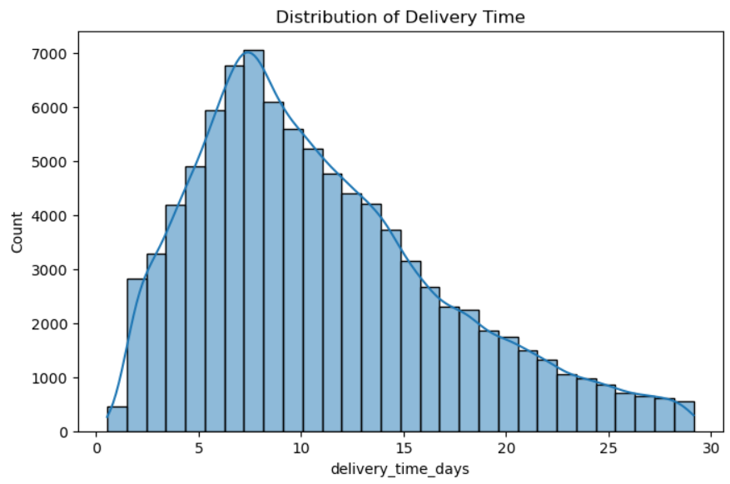

6. Boxplot Analysis
A boxplot was used to examine the spread and variability of delivery times.
Observations
- Median delivery time is approximately 10 days.
- Most observations fall between 6 and 15 days.
- Limited high-end delivery durations remain after preprocessing.
- Extreme outliers were significantly reduced during Week 2.
Interpretation
The boxplot confirms that delivery performance is relatively consistent for most orders. The preprocessing steps improved dataset quality by reducing the influence of extreme delivery durations.
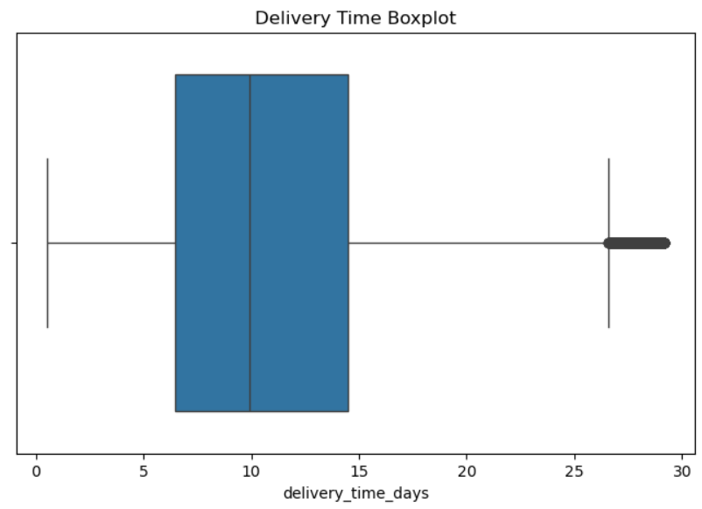

7. Correlation Analysis
A correlation heatmap was generated to identify relationships among variables.

Notable Correlation Values
Variables | Correlation
total_price ↔ payment_value | 1.00
avg_price ↔ payment_value | 0.92
estimated_delivery_days ↔ delivery_time_days | 0.46
distance_km ↔ delivery_time_days | 0.45
same_state ↔ delivery_time_days | -0.44
Interpretation
The heatmap revealed a moderate positive relationship between estimated delivery duration and actual delivery time. Distance also positively influences delivery duration. In contrast, deliveries occurring within the same state generally require less time, resulting in a negative relationship with delivery duration.
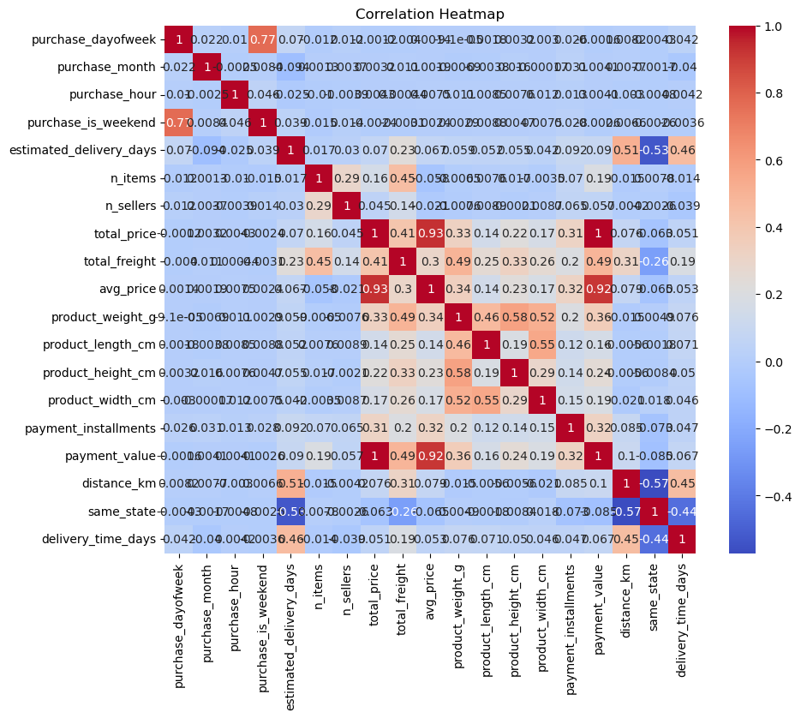

8. Distance vs Delivery Time Analysis
A scatter plot was generated to examine the relationship between distance and delivery duration.
Observations
- Delivery duration generally increases as distance increases.
- Most deliveries occur within lower normalized distance ranges.
- Long-distance deliveries tend to require additional delivery time.
Interpretation
The scatter plot demonstrates that delivery distance is an important factor affecting logistics performance. Longer transportation distances generally contribute to increased delivery duration.
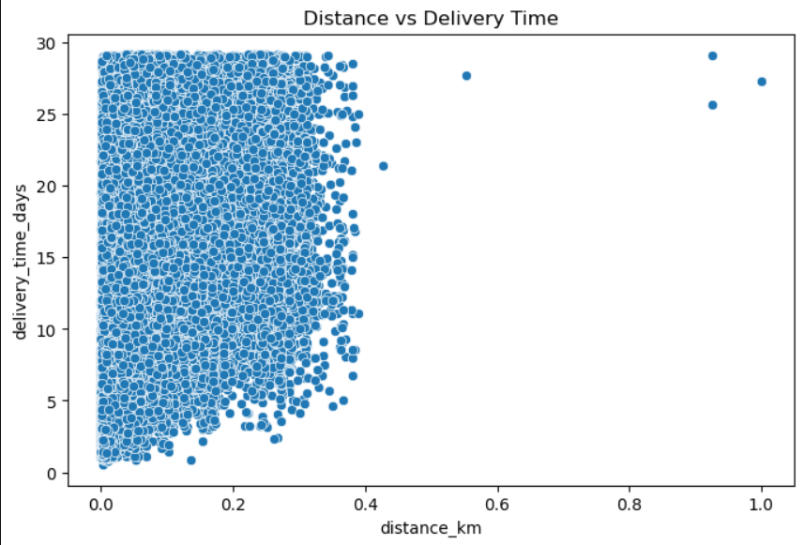

9. Monthly Order Analysis
Order patterns were analyzed using a count plot of monthly purchases.
Observations
- Month 8 recorded the highest order volume.
- Months 5 to 8 showed consistently high transaction activity.
- Month 9 recorded the lowest order volume.
- Customer demand varies throughout the year.
Interpretation
The monthly order trend suggests seasonal fluctuations in purchasing behavior. Understanding these patterns can help logistics companies improve resource planning and delivery scheduling.
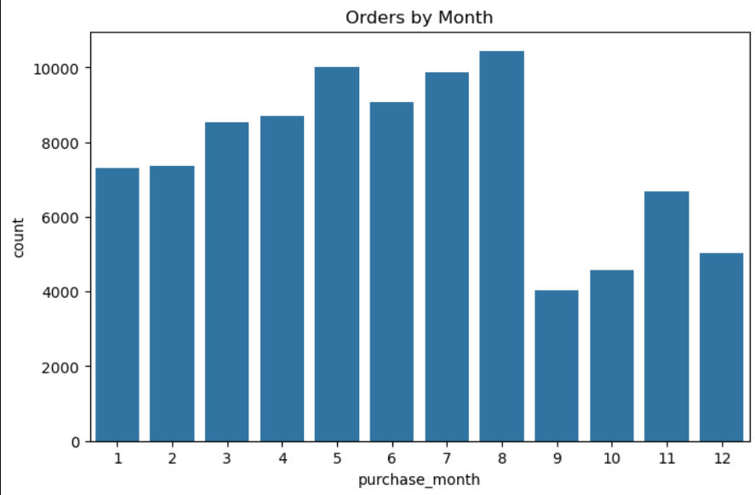

10. Business Insights

The analysis generated several valuable logistics insights:
- Most deliveries are completed within 5–15 days.
- Average delivery duration is approximately 11 days.
- Delivery distance has a moderate impact on delivery performance.
- Same-state deliveries are generally completed faster than interstate deliveries.
- Estimated delivery duration is a useful predictor of actual delivery performance.
- High order activity occurs between Months 5 and 8, indicating seasonal demand patterns.
- Payment value is strongly associated with product pricing variables.
These findings can assist logistics organizations in improving delivery planning and operational efficiency.
Orders peaked during Month 8, indicating a period of high logistics demand. Logistics providers should consider allocating additional transportation resources and personnel during peak-order months to maintain delivery performance.
11. Python Code Illustration

Descriptive Statistics
df['delivery_time_days'].mean()
df['delivery_time_days'].median()
df['delivery_time_days'].mode()

Histogram
sns.histplot(df['delivery_time_days'], bins=30, kde=True)

Boxplot
sns.boxplot(x=df['delivery_time_days'])

Correlation Heatmap
sns.heatmap(df.corr(), annot=True)

Scatter Plot
sns.scatterplot(
x='distance_km',
y='delivery_time_days',
data=df)

Monthly Orders
sns.countplot(
x='purchase_month',
data=df
)

12. Conclusion
This phase focused on exploring and visualizing logistics data to identify meaningful business insights. Statistical analysis revealed that the average delivery duration was approximately 11 days, with most deliveries completed between 5 and 15 days. Correlation analysis confirmed that delivery distance and estimated delivery duration are important factors influencing actual delivery time.
The generated visualizations provided valuable insights into delivery performance, demand patterns, and operational behavior. These findings will support the next phase of the project, where machine learning models will be developed to predict delivery times and recommend logistics optimization strategies.

